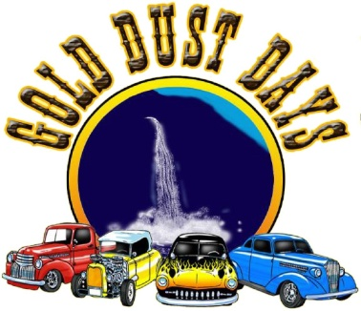  50 / 50 RAFFLE | SHOW-N-SHINE REGISTRATION  Gold Bar, WA
 | Saturday July 27, 2019 9am - 3pm
 | Breakfast will be served at the VFW Hall
 | 7:30am - 9:30am. By Donation ($5 minumum suggested)

Name: _____________________________________________________________________________
Email: __________________________________________ Phone: ____________________________
Address: ____________________________________________________________________________
City: ___________________________________________ State: ________ Zip: _______________

Vehicle Information
Year: ___________________________________________ Make: ______________________________
Model: ______________________________________________________________________________
Special Features: ______________________________________________________________________
Car Club: ____________________________________________________________________________
Registration Category(Select from 2nd Page): ______________________________________________

Pre-Registration Fee: $15.00 Day of Show: $20.00
Make Checks to: Sky Valley Chamber of Commerce
Car Show Registration: P.O. Box 46, Sultan WA 98294
For more information contact: Debbie@SkyValleyVIC.net or call 360-793-0983

