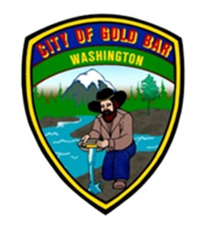

CALL FOR PUBLIC PARTICIPATION
City of Gold Bar, Washington

The City of Gold Bar is updating the Shoreline Master Program (SMP) for the City’s shoreline along the Skykomish River, Wallace River, and May Creek. The SMP determines the types and uses of shoreline development, provides for public access, and increases opportunities for restoration.

The SMP update must be completed by June 30, 2019. Revision is necessary to keep the SMP current with the rules and guidelines of the Department of Ecology, the City’s Comprehensive Plan, and the City’s development regulations. The proposed revisions to the SMP are minor procedural changes that will make the document more accessible for users and more consistent with state regulations.

All are invited to learn more about the SMP update at a series of events from December 3rd through December 7th. At each event, information about the proposed revisions will be available for review and there will be an opportunity to provide feedback. The City seeks information from residents and other stakeholders about the proposed updates for the SMP and about their experience with shorelines in Gold Bar.

OPEN HOUSE AND CITY COUNCIL MEETING

WHEN: Tuesday, December 4th, 2018, 5:30pm – 6:45 pm
Open House to learn about the revisions, ask questions and provide feedback

The SMP Update will also be on the agenda for the regularly scheduled City Council Meeting immediately following the Open House at 7pm.

WHERE Gold Bar City Hall
107 Fifth Street
Gold Bar, WA 98251

INFORMATIONAL POSTERS ON DISPLAY FOR REVIEW AND COMMENT AT GOLD BAR CITY HALL

WHEN: Monday, December 3 – Friday, December 7, 2018
during opening hours

WHERE: Gold Bar City Hall
107 Fifth Street
Gold Bar, WA 98251

